Chapter 5

# Try It Yourself: Summarize a Quantitative Variable by a Categorical Variable

## Excel Instructions

1. Open Products.csv in Excel.
2. What is the average price (Price) for a CategoryID of 7?
   1. Verify the first row of Column D is labeled CategoryID and the first row of Column F is labeled Price.
   2. Select Columns D through F. First select the “D” at the top of Column D. Then, hold down the 'Shift' key on your keyboard, and while holding it, click on the “F” at the top of Column F. This action will extend the selection to include Columns D, E, and F. We will not use Column E; we include it because Excel requires consecutive columns.
   3. From the Excel ribbon at the top, go to ‘Insert → ‘Pivot Table’.
   4. Choose ‘From Table/Range’.

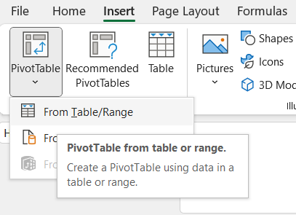

* 1. Accept the Table/Range of “Products!$D:$F” and the default of “New Worksheet”; do not change any other options.
  2. Select OK.

* 1. You will see a new Pivot Table sheet.

* 1. You can modify your Pivot Table using the PivotTable Fields panel on the right.
  2. Drag CategoryID from the right-hand menu under ‘PivotTable Fields’ to the box below called “Rows.” This indicates the variable by which you want to group your data.
  3. Drag Price from the right-hand menu under ‘PivotTable Fields’ to the box below called “Values.” This indicates the variable you wish to take an average of.
  4. In the same Values box on the lower-right side, select the dropdown next to ‘Sum of Price’ → ‘Value Field Settings…’ A screenshot of a computer

     Description automatically generated
  5. Choose “Average.”
  6. Click ‘OK’.

1. Repeat these steps for a CategoryID of 8.